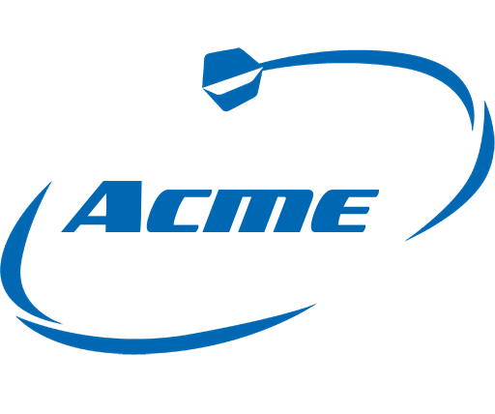

Acme Corp.
Richardson, tx 75081
info@xyzcorp.com | www.xyzcorp.com
222 555 7777

BUSINESS PROPOSAL

Prepared by:
Susan Cole
[PROJECT_NAME]
{{CLIENT_NAME}}

[DATE]

- Executive Summary
Acme Corp. is pleased to present this comprehensive business proposal. We are a technology solutions company with a mission to empower businesses through innovative technology solutions. Our dedicated team brings a wealth of experience and a passion for cutting-edge technology. In this proposal, we outline our vision, market research, products/services, marketing and sales strategies, financial projections, funding request, implementation plan, and risk analysis.

- Company Overview
  - History and Background
Acme Corp. was founded in 2060 by James Donelly with the goal of revolutionizing the technology industry. Since our inception, we have consistently delivered state-of-the-art solutions and expanded our client base to include Fortune 500 companies.
  - Mission and Vision
- Mission: To deliver innovative technology solutions that transform businesses.
- Vision: To become a global leader in technology-driven business solutions.

  - Core Values
At Acme Corp., we uphold the following core values:
- Integrity
- Innovation
- Customer-Centric
- Sustainability
- Teamwork

  - Team
Meet the key members of our leadership team:
Name | Title | Background
James Donelly | CEO | A visionary leader with 20+ years of tech experience
Annette Davis | COO | A seasoned operations expert with a proven track record
Nancy Caswell | CMO | A marketing guru with a history of successful campaigns
Parker Alexander | CFO | A financial strategist with a sharp focus on growth

- Market Research and Analysis
  - Market Trends
The technology industry is witnessing a surge in demand for AI-driven solutions, cloud computing, and cybersecurity services.

  - Target Audience
Our ideal customers are medium to large businesses seeking scalable technology solutions to streamline operations.

  - Competitive Analysis
Our competitors, such as TechSolutions Inc. and InnovateTech, offer similar services. However, we differentiate ourselves through our focus on personalized customer service and innovative solutions.

  - SWOT Analysis
Strengths | Weaknesses
Expert Leadership | Limited marketing budget
Innovative Solutions | Reliance on a few key clients
Strong Client Relationships | Limited brand recognition

Opportunities | Threats
Growing Market Demand | Intense competition
Expanding Our Product Line | Economic Downturn
Strategic Alliances | Technological Disruptions

- Products/Services
  - Product/Service Description
Acme Corp. offers a range of technology services, including custom software development, cloud infrastructure management, cybersecurity solutions, and AI-driven analytics.

  - Unique Selling Proposition (USP)
Our USP lies in our ability to tailor technology solutions to meet the unique needs of each client. We work closely with our clients to understand their challenges and deliver bespoke solutions that drive success.

- Marketing and Sales Strategy
  - Marketing Plan
Our marketing strategy involves targeted online and offline campaigns, content marketing, and participation in industry events. We will allocate 15% of our budget to marketing activities.

  - Sales Strategy
Our sales team will focus on building strong client relationships, offering personalized solutions, and expanding our portfolio of services. We aim to achieve a 20% growth in sales annually.

- Financial Projections
  - Income Statement
Our income statement projection for the next 3 years indicates steady revenue growth, with an expected annual increase of 15%.

 | Year 1 | Year 2 | Year 3
Revenue | $1,000,000 | $1,200,000 | $1,440,000
Cost of Goods Sold | $400,000 | $480,000 | $576,000
Gross Profit | $600,000 | $720,000 | $864,000
Operating Expenses | $400,000 | $450,000 | $500,000
EBITDA | $200,000 | $270,000 | $364,000
Interest Expense | $20,000 | $18,000 | $16,000
Net Income Before Tax | $180,000 | $252,000 | $348,000
Income Tax (30%) | $54,000 | $75,600 | $104,400
Net Income | $126,000 | $176,400 | $243,600

  - Balance Sheet
The balance sheet projection reveals healthy financial stability, with a positive cash flow.
 | Year 1 | Year 2 | Year 3
Assets
Current Assets | $500,000 | $600,000 | $720,000
Fixed Assets | $400,000 | $480,000 | $576,000
Total Assets | $900,000 | $1,080,000 | $1,296,000
Liabilities
Current Liabilities | $300,000 | $360,000 | $432,000
Long-Term Liabilities | $200,000 | $180,000 | $160,000
Total Liabilities | $500,000 | $540,000 | $592,000
Equity
Owner's Equity | $400,000 | $540,000 | $704,000
Total Liabilities & Equity | $900,000 | $1,080,000 | $1,296,000

  - Cash Flow Statement
Our cash flow statement projection indicates that we will maintain a strong financial position with ample working capital.
 | Year 1 | Year 2 | Year 3
Cash Flow from Operations
Net Income | $126,000 | $176,400 | $243,600
Depreciation | $40,000 | $45,000 | $50,000
Changes in Working Capital | $10,000 | $12,000 | $14,000
Cash Flow from Operations | $176,000 | $233,400 | $307,600
Cash Flow from Investing
Capital Expenditures | ($80,000) | ($96,000) | ($115,200)
Cash Flow from Investing | ($80,000) | ($96,000) | ($115,200)
Cash Flow from Financing
New Equity Funding | $200,000
Loan Repayments | ($20,000) | ($18,000) | ($16,000)
Cash Flow from Financing | $180,000 | ($18,000) | ($16,000)
Net Cash Flow | $276,000 | $119,400 | $176,400
Cash at Beginning of Year | $100,000 | $376,000 | $495,400
Cash at End of Year | $376,000 | $495,400 | $671,800

- Funding Request
  - Funding Purpose
We are seeking $2 million in equity funding to expand our service offerings, hire additional talent, and invest in marketing and sales efforts.

  - Funding Amount
We are seeking $2,000,000 in equity funding.

  - Repayment Plan
The investment will be repaid in five years, with quarterly payments starting one year after the investment is received.

- Implementation Plan
  - Timeline
We have outlined a detailed implementation plan, which includes product development, marketing campaigns, and client acquisition, over the next 12 months.

  - Milestones
Our milestones include the launch of new services, the acquisition of 20 new clients, and achieving profitability within the first two years.

  - Responsibilities
We have designated specific team members to oversee each aspect of the implementation plan to ensure smooth execution.

- Risk Analysis and Mitigation
  - Identified Risks
- Market saturation
- Economic downturn
- Technological disruptions
  - Mitigation Strategies
We will continuously monitor market conditions, diversify our service offerings and invest in ongoing training to stay ahead of technological advancements.

- Appendix
  - Resumes
Appendices include resumes of key team members, showcasing their expertise and experience.

  - References
References from satisfied clients and partners who have experienced success with our services.

  - Additional Information
Any additional documents or information relevant to the proposal, such as case studies or awards.

